1.Read an integer and determine whether it is positive, negative, or zero. If it is positive, also state whether it is even or odd.
FlowChart:

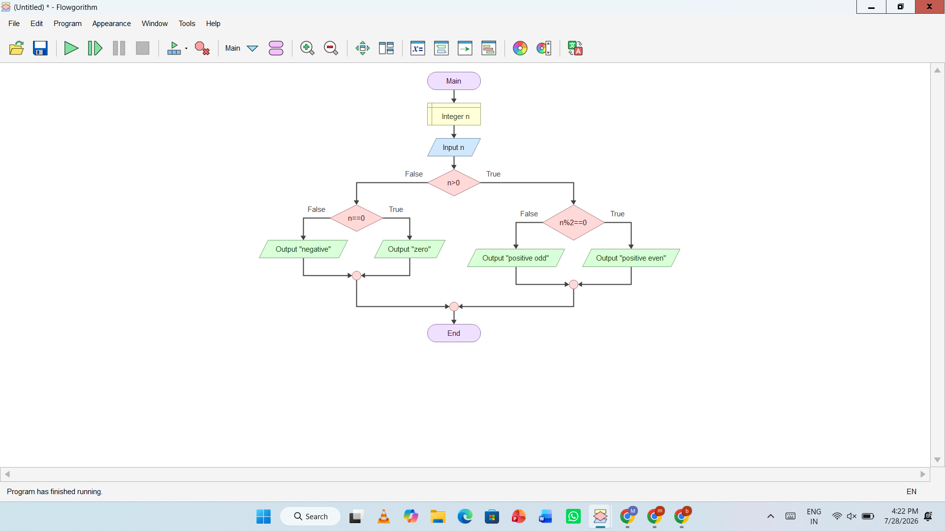
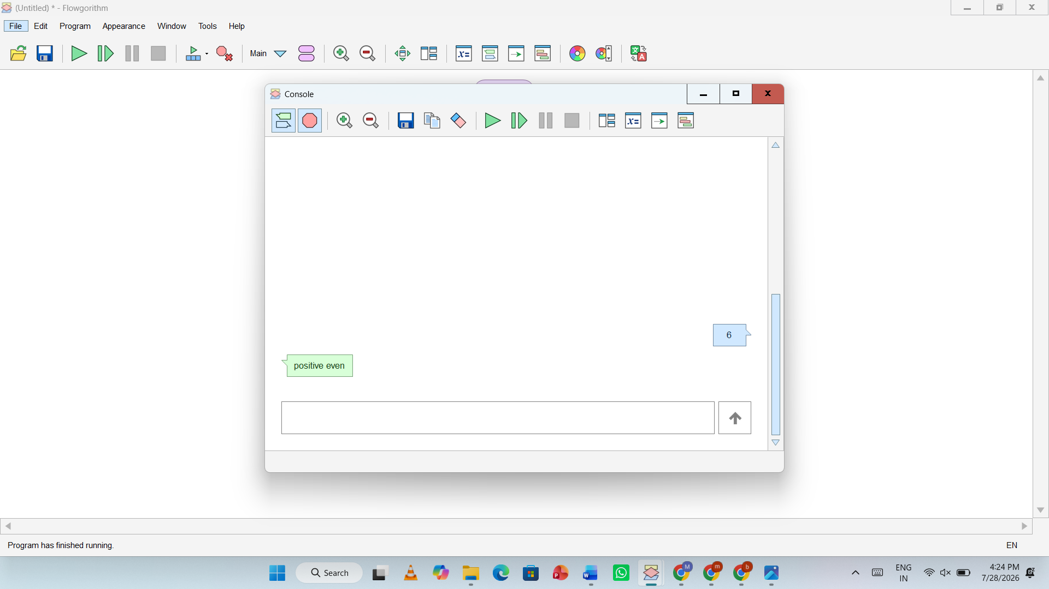
Pseudocode
Start

Declare integer array numbers[10]
Declare integer i
Declare integer positive = 0
Declare integer negative = 0
Declare integer zero = 0

For i = 0 to 9
Input numbers[i]

If numbers[i] > 0 Then
positive = positive + 1
Else If numbers[i] < 0 Then
negative = negative + 1
Else
zero = zero + 1
End If
End For

Output "Positive numbers = ", positive
Output "Negative numbers = ", negative
Output "Zero values = ", zero

End

Java Program
import java.util.Scanner;

public class CountNumbers {
public static void main(String[] args) {

Scanner sc = new Scanner(System.in);

int[] numbers = new int[10];
int positive = 0;
int negative = 0;
int zero = 0;

System.out.println("Enter 10 integers:");

for (int i = 0; i < 10; i++) {
numbers[i] = sc.nextInt();

if (numbers[i] > 0) {
positive++;
} else if (numbers[i] < 0) {
negative++;
} else {
zero++;
}
}

System.out.println("Positive numbers = " + positive);
System.out.println("Negative numbers = " + negative);
System.out.println("Zero values = " + zero);

sc.close();
}
}
2. Read 10 integers into an array and count how many are positive, negative, and zero.
Flowchart:
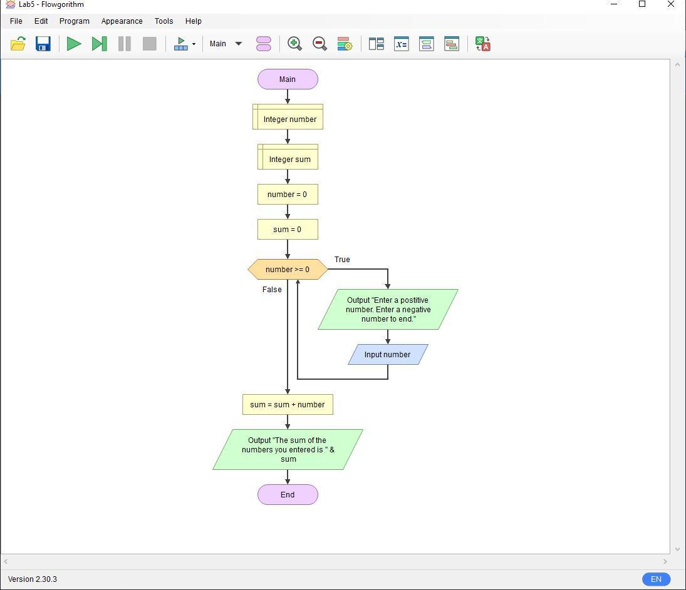

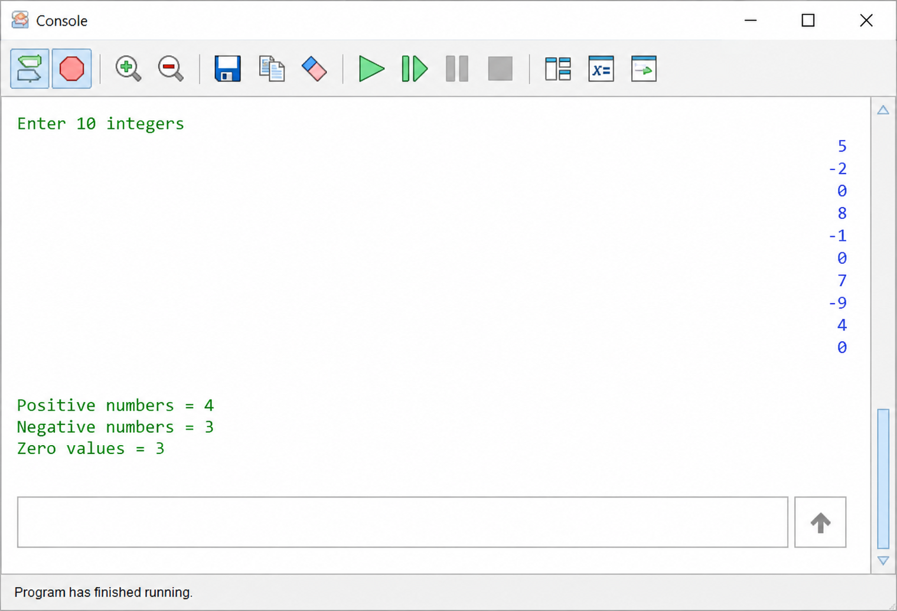

Pseudo Code
START
Declare integer array arr[10]
Declare integer i
Declare integer positive = 0
Declare integer negative = 0
Declare integer zero = 0

FOR i = 0 TO 9
Read arr[i]

IF arr[i] > 0 THEN
positive = positive + 1
ELSE IF arr[i] < 0 THEN
negative = negative + 1
ELSE
zero = zero + 1
END IF
END FOR

Display "Positive numbers = ", positive
Display "Negative numbers = ", negative
Display "Zero values = ", zero

STOP

Java Program
import java.util.Scanner;

public class CountNumbers {
public static void main(String[] args) {

Scanner sc = new Scanner(System.in);

int[] arr = new int[10];
int positive = 0;
int negative = 0;
int zero = 0;

System.out.println("Enter 10 integers:");

for (int i = 0; i < 10; i++) {
arr[i] = sc.nextInt();

if (arr[i] > 0) {
positive++;
} else if (arr[i] < 0) {
negative++;
} else {
zero++;
}
}

System.out.println("Positive numbers = " + positive);
System.out.println("Negative numbers = " + negative);
System.out.println("Zero values = " + zero);

sc.close();
}
}

3.Create a function that returns the larger of two integers and another that returns the larger of three integers. Explain how these could be written as overloaded max methods in Java.
Flowchart:
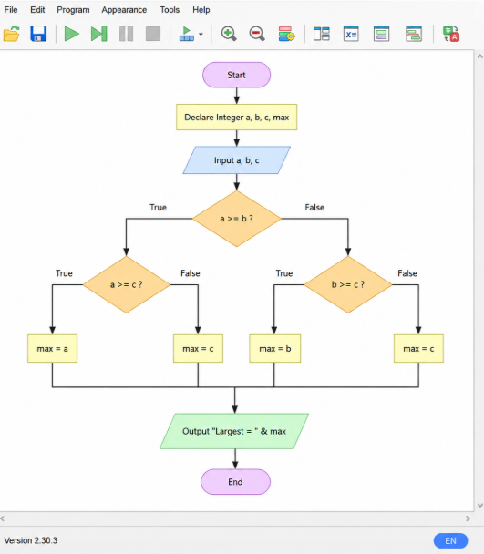

Pseudo Code
START

FUNCTION max(a, b)
IF a > b THEN
RETURN a
ELSE
RETURN b
END IF
END FUNCTION

FUNCTION max(a, b, c)
IF a > b AND a > c THEN
RETURN a
ELSE IF b > c THEN
RETURN b
ELSE
RETURN c
END IF
END FUNCTION

Declare Integer a, b, c
Declare Integer largest2, largest3

Output "Enter first number:"
Input a

Output "Enter second number:"
Input b

largest2 = max(a, b)

Output "Largest of two numbers = ", largest2

Output "Enter third number:"
Input c

largest3 = max(a, b, c)

Output "Largest of three numbers = ", largest3

STOP

Java Code
import java.util.Scanner;

public class MaxOverloading {

static int max(int a, int b) {
if (a > b)
return a;
else
return b;
}
static int max(int a, int b, int c) {
if (a > b && a > c)
return a;
else if (b > c)
return b;
else
return c;
}

public static void main(String[] args) {

Scanner sc = new Scanner(System.in);

System.out.print("Enter first number: ");
int a = sc.nextInt();

System.out.print("Enter second number: ");
int b = sc.nextInt();

System.out.println("Largest of two numbers = " + max(a, b));

System.out.print("Enter third number: ");
int c = sc.nextInt();

System.out.println("Largest of three numbers = " + max(a, b, c));

sc.close();
}
}

